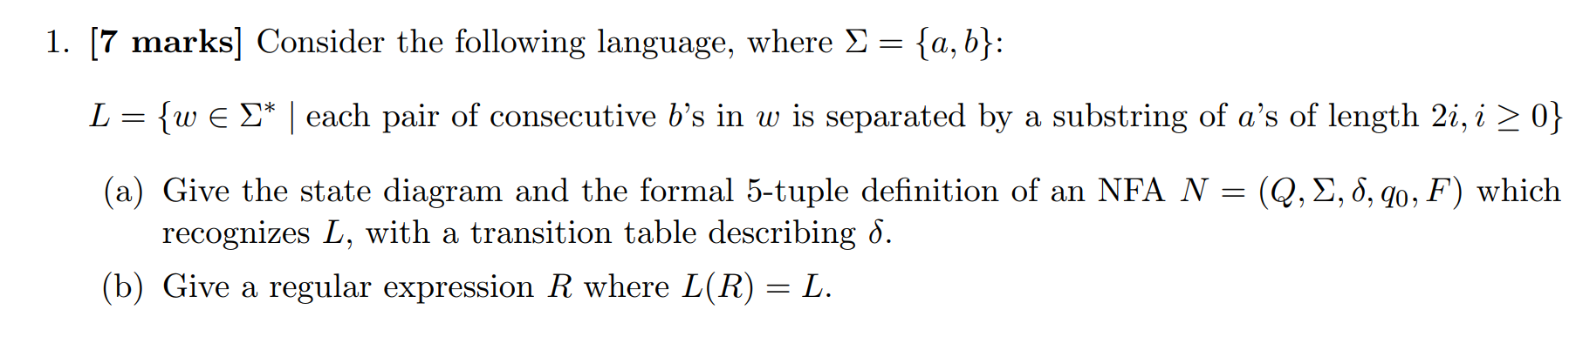
My Solution 1(a)

NFA N = (Q, Σ, δ, q0, F) is defined by ({Q₀,Q₁,Q₂,Q₃,Q₄,Q₅},{a,b},δ, Q₀, {Q₀,Q₁,Q₅}) where δ can be expressed in a transition table as

States | a | b | ε
Q₀ | {Q₀, Q₁} | Q₁ | ∅
Q₁ | Q₁ | Q₂ | ∅
Q₂ | Q₄ | Q₃ | ∅
Q₃ | Q₄ | ∅ | ∅
Q₄ | Q₅ | ∅ | ∅
Q₅ | ∅ | ∅ | {Q₁, Q₃}

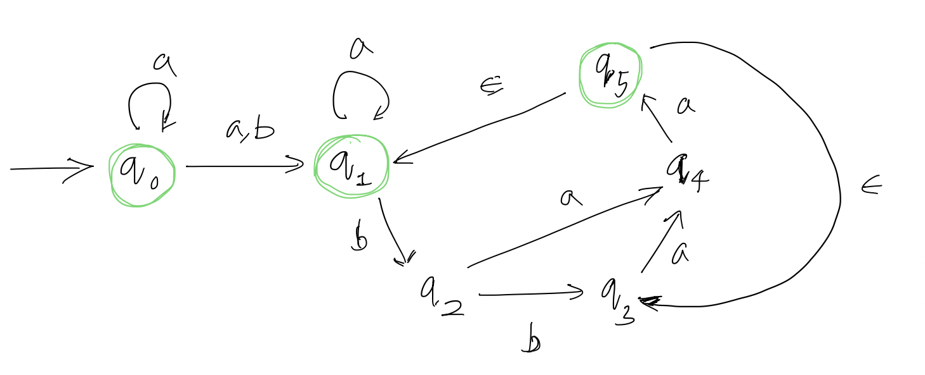

Please Turn Over

My Solution 1(b)
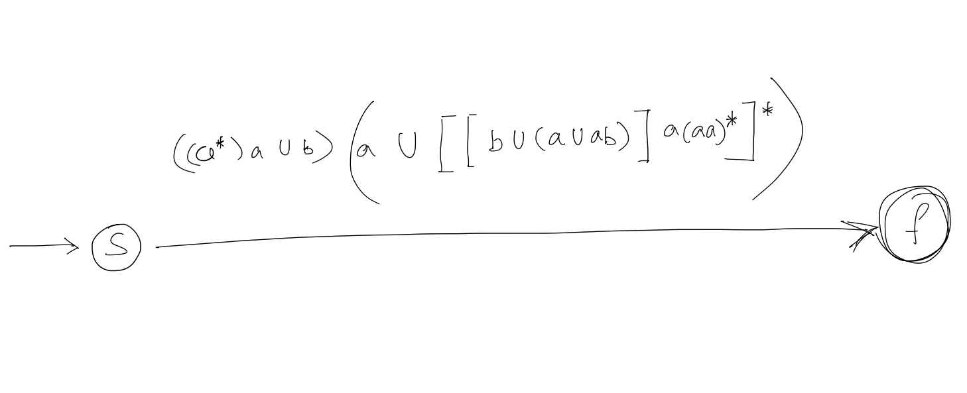
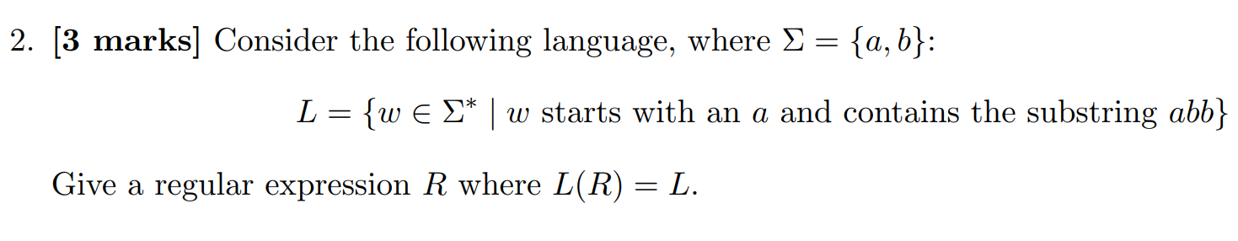

My Solution 2: [ (a ∪ b)* (abb) (a ∪ b)* ]

Example(s): a(abb)a, aab(abb)ba, aaaabbbb(abb)bbbbaaaa

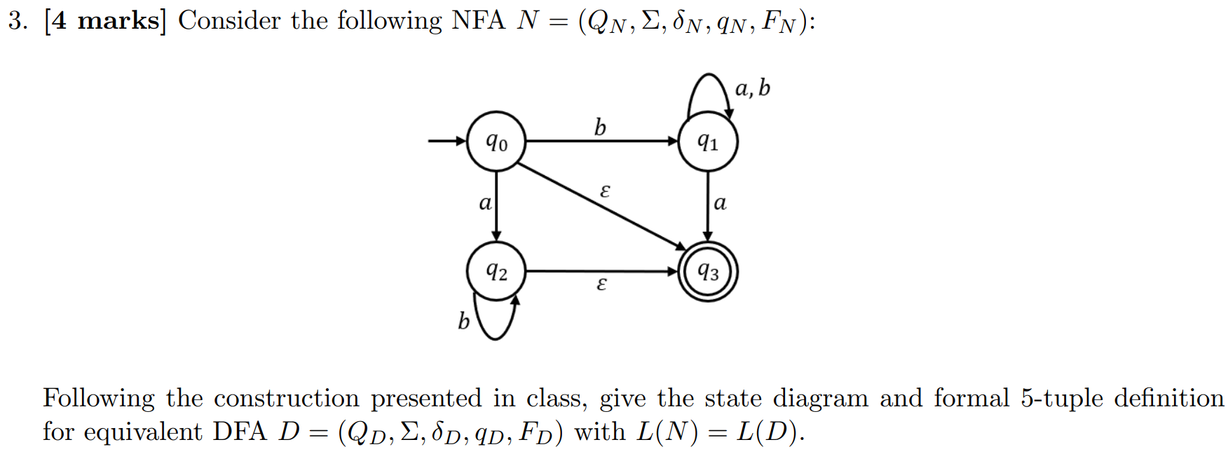

Please Turn Over
My Solution 3:
NFA N = (Q_{N}, Σ, δ_{N}, q_{N}, F_{N}) is defined by ({Q₀,Q₁,Q₂,Q₃}{a,b},δ, Q₀, {Q₃}) where δ can be expressed as in a transition table as

States | a | b | ε
Q₀ | Q₂ | Q₁ | Q₃
Q₁ | {Q₁,Q₃} | Q₁ | ∅
Q₂ | ∅ | Q₂ | Q₃
Q₃ | ∅ | ∅ | ∅

Now NFA N can be expressed as DFA D and can be defined by ({Q₁, {Q₀,Q₃},{Q₁,Q₃},{Q₂,Q₃},∅},{a,b},δ, Q₀,{Q₀,Q₃},{Q₁,Q₃},{Q₂,Q₃}) where δ can be expressed as in a transition table as:

States | a | b
Q₁ | {Q₁,Q₃} | Q₁
{Q₀,Q₃} | {Q₂,Q₃} | {Q₁,Q₃}
{Q₁,Q₃} | {Q₁,Q₃} | Q₁
{Q₂,Q₃} | ∅ | {Q₂,Q₃}
∅ | ∅ | ∅
The state diagram along with the final states in red as:
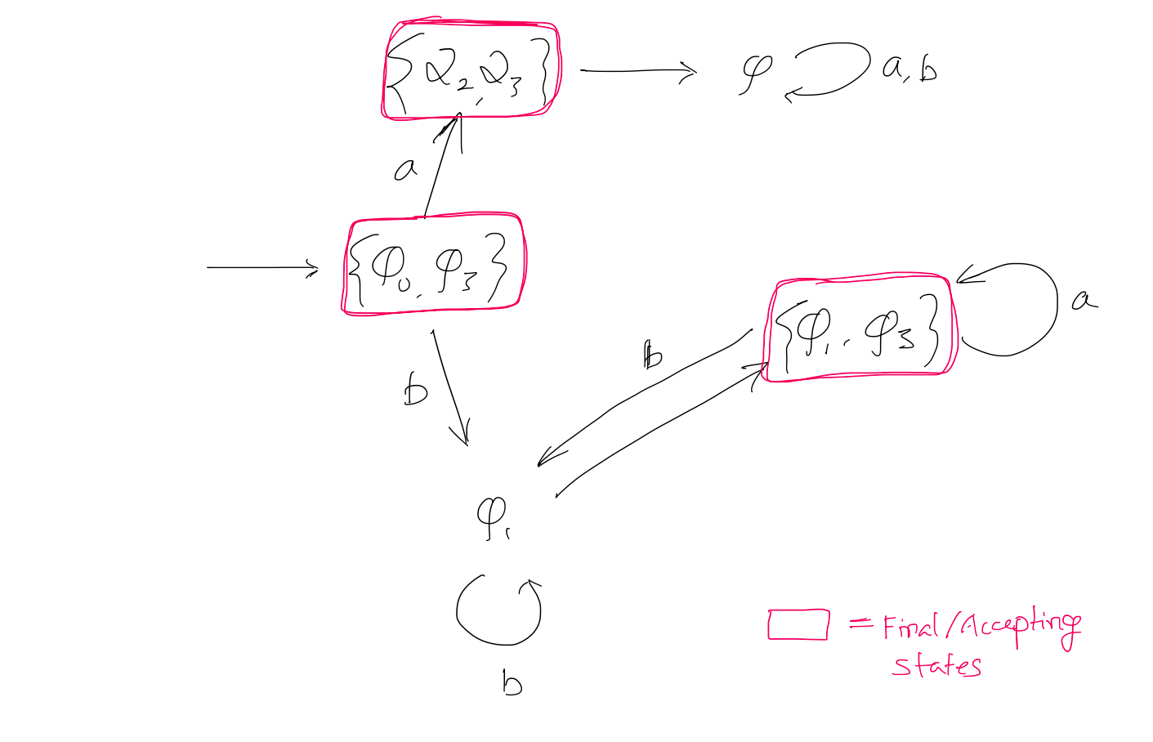
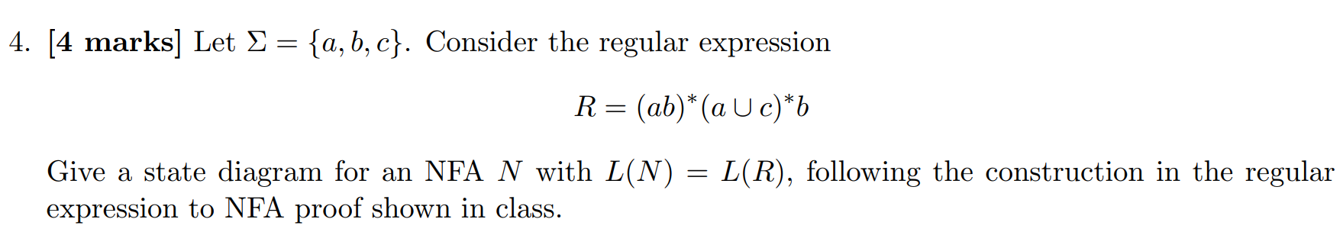

My Solution 4:

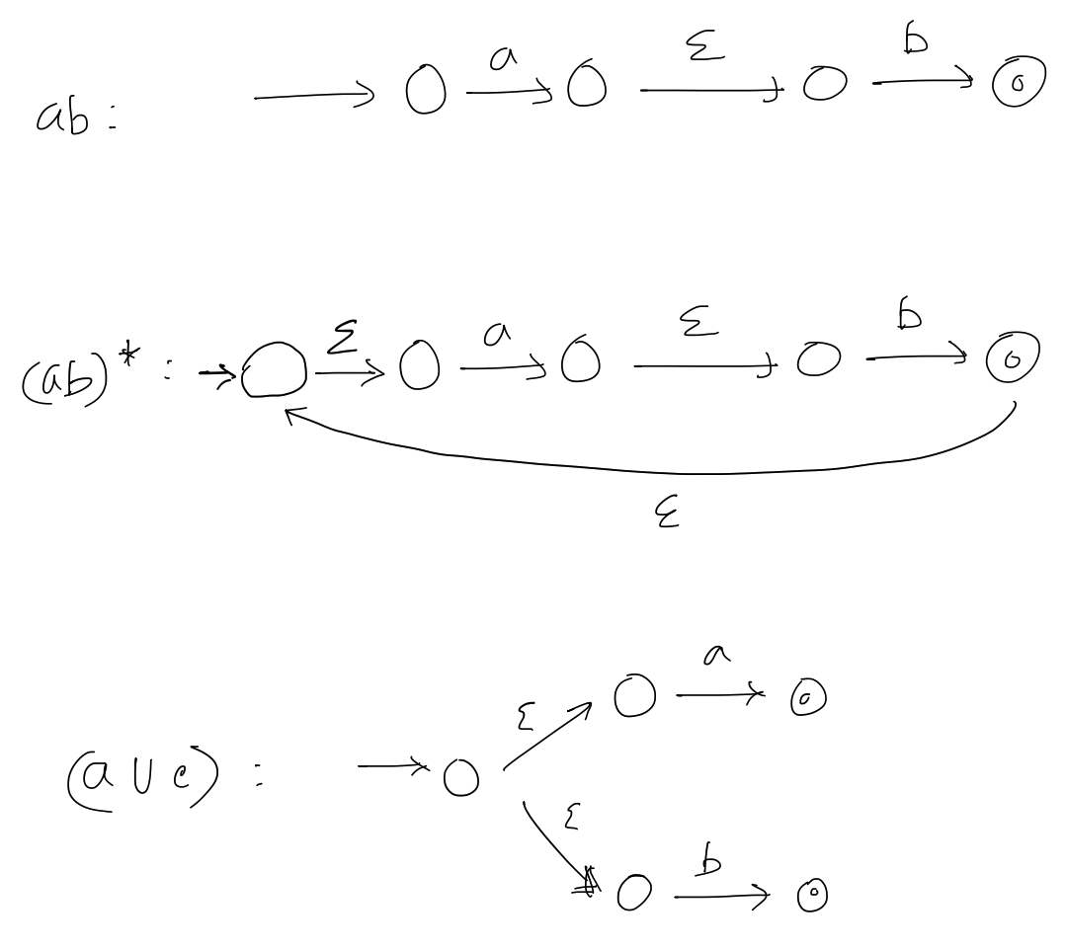

Please Turn Over

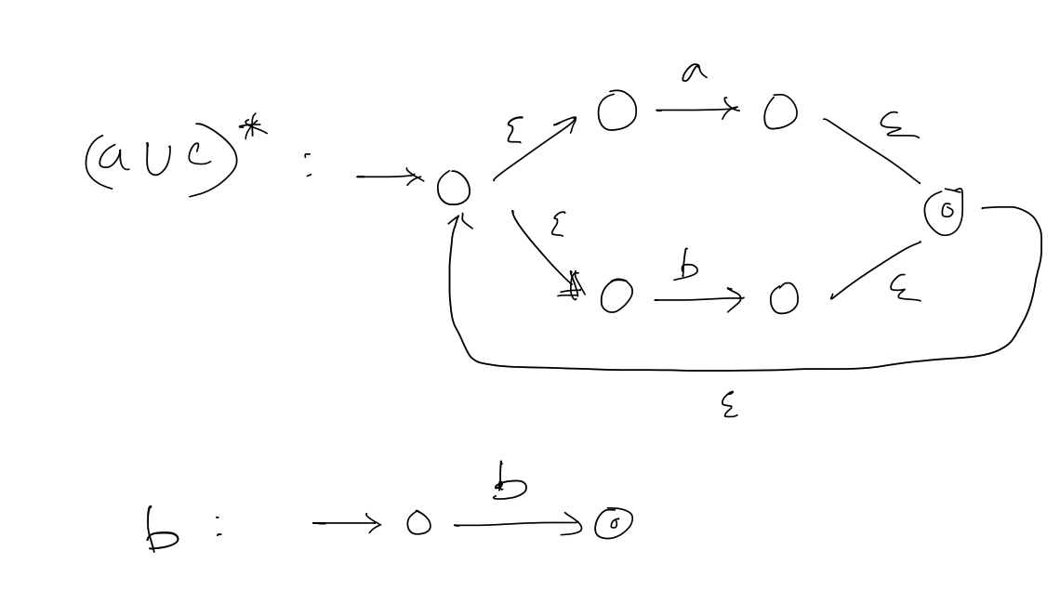

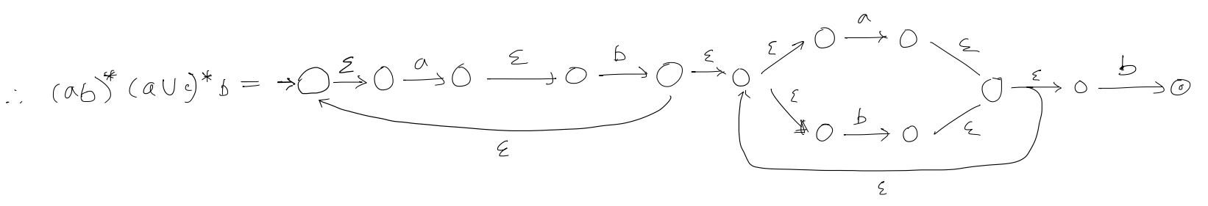

I followed the state diagrams figures and replicated them in my solution.

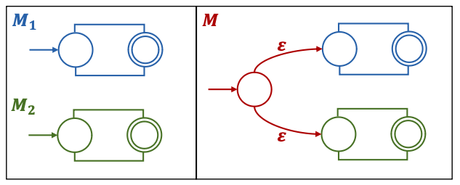

Please Turn Over
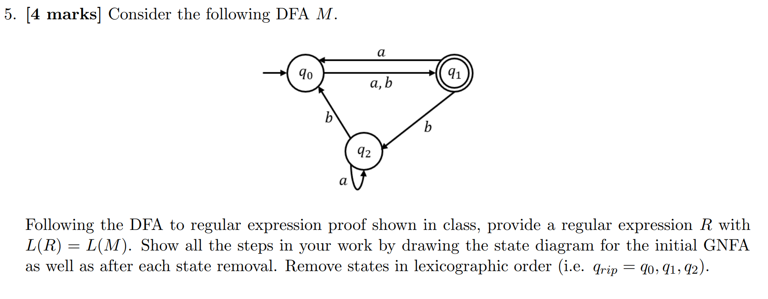

My Solution 5:
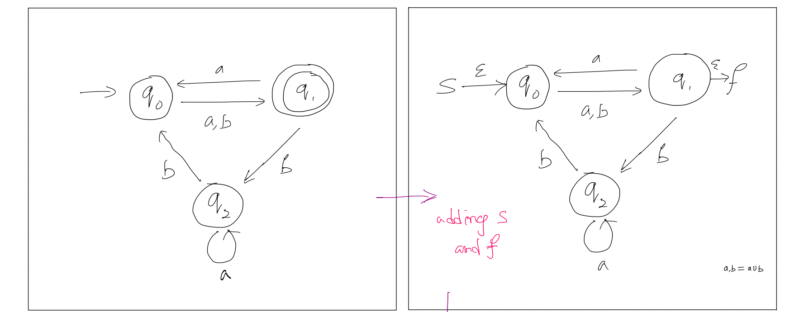
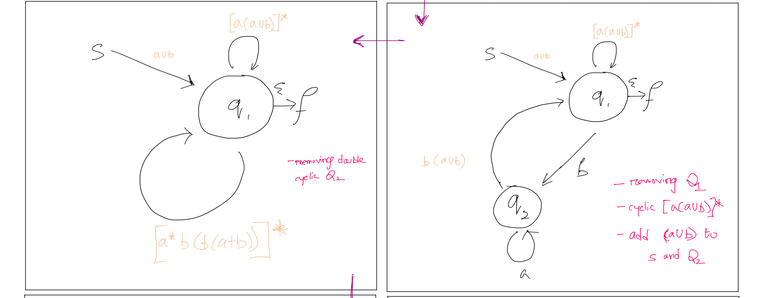
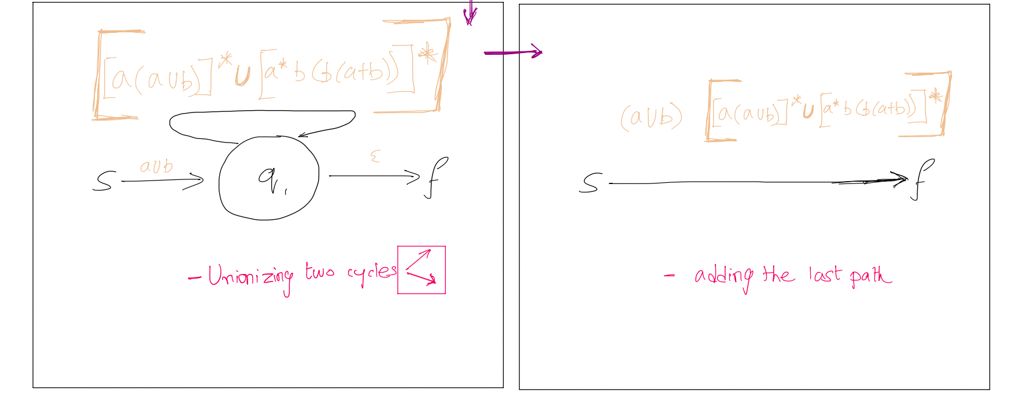

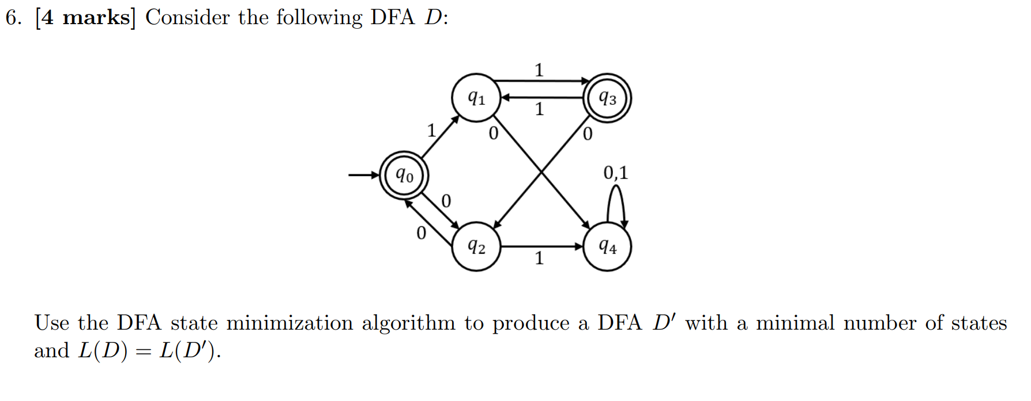
My Solution 6:
We can write the transition state for the DFA D in the following way:
States | 1 | 0
Q₀ | Q₁ | Q₂
Q₁ | Q₃ | Q₄
Q₂ | Q₄ | Q₀
Q₃ | Q₁ | Q₂
Q₄ | Q₄ | Q₄

0 Equivalence through separating the normal and the final states = {Q₁, Q₂, Q₄} {Q₀, Q₃}
1 Equivalence through separating the normal states associated = {Q₁} {Q₂} {Q₀, Q₃} {Q₄}
2 Equivalence through separating the normal states associated = {Q₁} {Q₂} {Q₀, Q₃} {Q₄}
… 2 Equivalence through separating the normal states associated = {Q₁} {Q₂} {Q₀, Q₃} {Q₄}

States | 1 | 0
Q₀Q₃ | Q₁ | Q₂
Q₁ | Q₀Q₃ | Q₄
Q₂ | Q₄ | Q₀Q₃
Q₄ | Q₄ | Q₄

And here’s the minimized DFA for the given D:
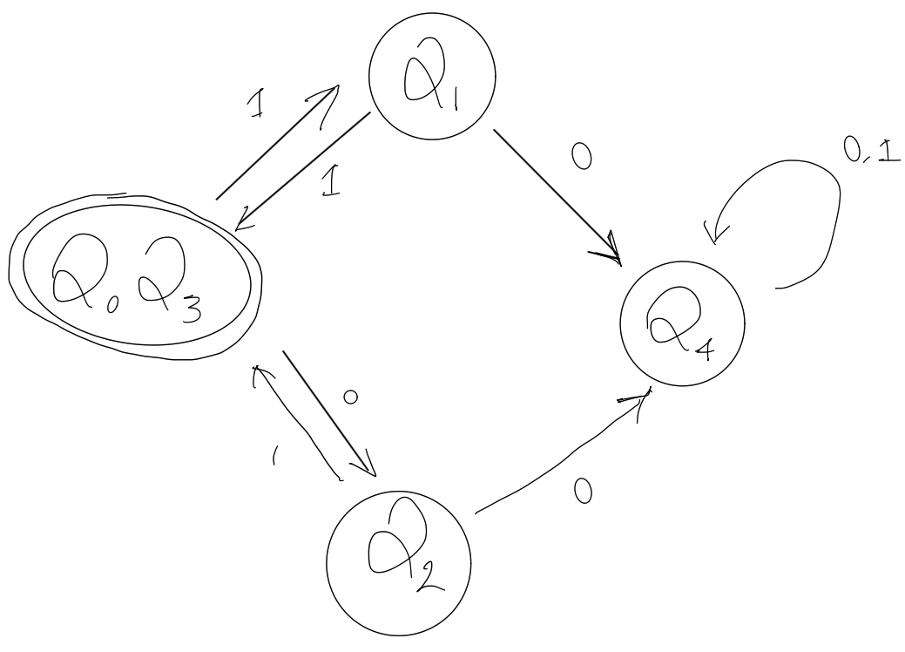

Please Turn Over

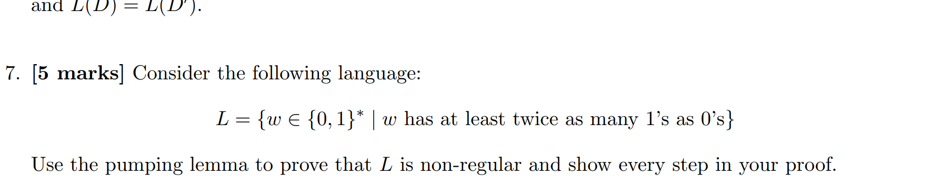
My Solution 7:

Assuming L is regular and letting p be the pumping length by the pumping lemma we choose a string a^{p}(abb). Since |s| >= p, the pumping lemma says that s can be split into 3 parts xyz where
|xy| <= p
|y| >0
xy^{iz} is in L for all i >=0

The analysis considers all possible substrings 'y' within the language 'L' defined by the condition of containing the substring 'abb'. If 'y' contains only 'a's, pumping it will violate the condition by introducing more 'a's than 'b's. Similarly, if 'y' consists solely of 'b's, pumping it will disrupt the 'abb' substring. Even if 'y' contains 'ab', pumping will alter the balance of 'a's and 'b's, violating the condition. Thus, for every case, pumping 'y' results in strings outside of 'L', indicating that 'L' is non-regular.

